Model description:
The aim of the simulation is to calculate and compare the probability distributions of symptom combinations between individuals with and without inflammation in a fictitious mental disorder. The disorder is defined by 5 symptom criteria of which at least 2 must be present to fulfill diagnostic criteria. The disorder is simulated with a binary latent variable L, which is present in 80% of the simulated individuals.
Five symptom indicators are simulated: S1, S2, M, W1, and W2, where S stands for strong indicators, W for weak indicators, and M for a medium-strength indicator. Each symptom is influenced by both the disorder L and by a second binary latent variable I, which represents inflammation. Inflammation is present in 50% of individuals. The correlation between L and I is 0.6. Both latent variables act additively on the symptoms, with varying strengths of effect.
Symptoms are measured on a scale from 0 to 4, with values of 2 or higher indicating symptom presence. Symptom ratings are normally distributed around a mean of 2, with different standard deviations depending on indicator strength. The disorder is considered present if at least 2 of the 5 symptoms are present. The simulation calculates the probability of each symptom combination separately for individuals with and without inflammation.

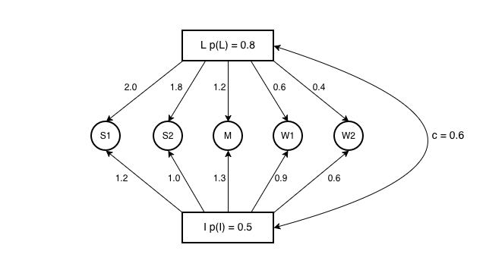
p(L) = Probability (prevalence) of latent variable L
p(I) = Probability (prevalence) of latent variable I
c = Correlation coefficient between L and I

